**Hiring Process**

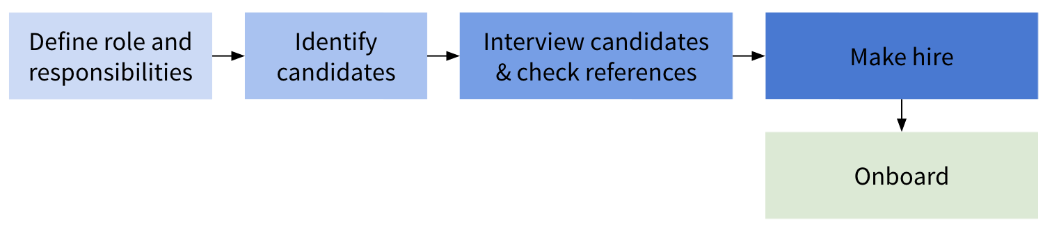

**Guide to Interviewing Senior Executives**

**Best Practices**

1. Remember that interviewing is a two-way process: an opportunity to inspire the candidate about working for the company (selling process), and an evaluation process.
2. Meet with candidate at least three times in three different circumstances.
3. Check at least three references, with preferably one or two that don’t come from the candidate.
4. Consider candidate’s strengths in a few areas:
   1. Domain expertise
   2. Culture fit
   3. Can-do attitude
   4. Emotional intelligence
5. Provide internal interview training to those involved in the interview process.
6. Go beyond standard interview questions to see the candidate in action. For example:
   1. Ask the candidate to make a presentation
   2. Give the candidate a problem situation and ask her to develop a range of solutions and a summary memo
   3. Conduct a role play on how to deal with a difficult employee
   4. Ask the person to facilitate a meeting with several other managers on a particular topic
7. Seek to understand their leadership style. (How do they think about and approach each of the 9 best leader competencies? E.g. taking initiative, team building, decision-making, etc.)
8. Prepare for the interview by clarifying your objectives, and collecting any background information. Document the discussion immediately after the interview to capture insights and remember follow-up items.

**Potential Questions**

1. Tell me about a time when you thought that the standard way of doing things might not be the best way, and you were responsible for driving change in a line of business or company.
   1. What led you to believe this? What was the business situation or problem?
   2. How did you create and communicate your new solution?
   3. Why did you do it this way?
   4. What issues did you run into with other people when trying to get things done?
   5. Were you able to encourage others to see your suggested change as a positive thing — although perhaps your idea impacted their work in a significant way?
   6. What was the overall result?
2. Tell me about a time when you identified a business opportunity which required the deployment of extra internal resources. What kind of support did you ask for and receive, and what was the outcome?
   1. What was the business situation or problem?
   2. How did you determine the opportunity was significant enough to warrant adding additional resources or building new capabilities in the business?
   3. What kind of support did you ask for and receive?
   4. How did you create and communicate the business case for new organizational capability?
   5. Why did you do it this way? What other options did you consider?
   6. What challenges did you run into when trying to build new internal capabilities?
   7. What was the overall result?
3. Assess their ability to solve a problem.
   1. Identify problems on the job. “Please walk me through the steps of the process that you’ll use during your first weeks to identify the most important current problems or opportunities in your area.”
   2. Solve a current problem. Provide them with a description of an actual problem that they will face on their first day. Then ask them to walk you through the broad steps they would take in order to solve the problem.
   3. Identify the problems in a process. Hand them a single-page description of a flawed existing process related to their job. Ask them to examine the process and identify the top three areas where they predict serious problems are likely to occur.
4. Evaluate whether they’re forward-looking.
   1. Outline your plan for this job over the first 3–6 months. Ask them to highlight key components, including goals, who they’ll consult with (by title), what data they’ll analyze, how they’ll communicate with their team, and the metrics for assessing their plan’s success.
   2. Forecast the evolution of the job/industry. Project 3–5 major trends in our industry, and then forecast how the top firms will need to change over the next few years to meet those trends.
5. Learning: “Outline the steps you’d take to continuously learn and maintain your expert status in one important technical area.”
6. Agility: “Outline the steps you’d take to adapt when a dramatic unexpected change occurs in either technology or customer expectations.”
7. Innovation: “Outline the steps you’d take to increase innovation among your team to respond to increased competition or new technologies.”